DESIGN AND IMPLEMENTATION OF A SMART HOME AUTOMATION SYSTEM FOR CONTROLLING LIGHTS AND FANS USING MICROCONTROLLER AND IoT PLATFORM

BY
OGBU ALBERT TOOCHUKWU 2020/EN/14455

A RESEARCH PROJECT SUBMITTED TO THE DEPARTMENT OF ELECTRICAL AND ELECTRONICS ENGINEERING

ALEX EKWUEME FEDERAL UNIVERSITY NDUFU ALIKE, EBONYI STATE IN PARTIAL FULFILMENT OF THE REQUIREMENTS FOR THE AWARD OF BACHELOR OF ENGINEERING IN ELECTRICAL AND ELECTRONICS ENGINEERING

SUPERVISOR
ENGR. EZICHI SAMUEL

OCTOBER, 2025.

DECLARATION

I hereby Declare that this work “DESIGN AND IMPLEMENTATION OF A SMART HOME AUTOMATION SYSTEM FOR CONTROLLING LIGHTS AND FANS USING MICROCONTROLLER AND IoT PLATFORM” is the product of my own research efforts, undertaken under the supervision of ENGR. EZICHI SAMUEL and has not been presented elsewhere for the Award of a degree. All sources have been duly distinguished and appropriately acknowledged.

---------------------------------------
DATE
OGBU ALBERT TOOCHUKWU
2020/EN/14455

CERTIFICATION

This is to certify that the research work for this project titled “DESIGN AND IMPLEMENTATION OF A SMART HOME AUTOMATION SYSTEM FOR CONTROLLING LIGHTS AND FANS USING MICROCONTROLLER AND IoT PLATFORM” and the subsequent preparation of the project by OGBU ALBERT TOOCHUKWU with matriculation number 2020/EN/14455, in the Department of Electrical and Electronic Engineering, were carried out under the supervision of ENGR. EZICHI SAMUEL, in the Department of Electrical and Electronic Engineering, Alex Ekwueme Federal University, Ndufu-Alike, Ebonyi State.

…………………………….. …………………….
ENGR. EZICHI SAMUEL DATE
(Supervisor)

…………………………….. …………………….
ENGR. MARCEL EHEDURU DATE
(Departmental Project Coordinator)

…………………………….. …………………….
ENGR. DR. NNAEMEKA S. UGWUANYI DATE
(Head of Department, Electrical and Electronic Engineering)

ACKNOWLEDGEMENT

First of all, I sincerely thank God Almighty for his endless grace, strength, and guidance to finish this part of my studies.
A big thank you to my project supervisor, Engr. Ezichi Samuel, for his guidance and support, which really improved the standard of my work.
I also want to express my gratitude to our Head of Department (HOD), Engr. Dr. Nnaemeka S. Ugwuanyi, and all staff in the Department of Electrical and Electronics staff at Alex Ekwueme Federal University, Ndufu-Alike. Their dedication to quality education and willingness to share their knowledge have greatly influenced my research and project.
To my parents, Mr. and Mrs. Cyprian Eze, I owe you the biggest thank you for your endless support and encouragement, which have been a huge help in my academic journey. I appreciate the opportunities you’ve given me.
To my cousin brothers, Engr. Ifeanyi Ose (CEO of Peps Electricals), Orji Christian Chinaeme and Elom Kaosisochi Udu, thank you all for your immense support and encouragement through-out my stay.
To my friends, Okechukwu Emmanuel, Nwankwo Samuel, Henrietta Ihuoma, Ajana Clinton, Ezi Eberechukwu, Nsi Hilary, thank you all for your support and encouragement and to everyone else who played a role in this journey. I say thank you.
To my group colleagues, I truly appreciate your help and contributions in completing this research project. God bless you all.
Lastly, I want to give a shout-out to myself, Ogbu Albert Toochukwu, for reaching this goal. I’m really happy to have made those who believed in me proud. I put in a lot of hard work and never gave up.

TABLE OF CONTENTS

DECLARATION ii
CERTIFICATION iii
ACKNOWLEDGEMENT iv
TABLE OF CONTENTS v
LIST OF TABLES ix
LIST OF FIGURES x
LIST OF PLATES xi
ABSTRACT xii
CHAPTER ONE 1
INTRODUCTION 1
1.1 Background 1
1.1.1 Microcontrollers in Home Automation 1
1.1.2 IoT and Smart Homes 1
1.1.3 IoT Platforms for Home Automation 2
1.1.4 Blynk IoT Platform 2
1.1.5 Smart Home Automation System Design 2
1.1.6 Security Considerations 2
1.2 Problem Statement 3
1.3 Aim 3
1.4 Objectives 3
1.5 Scope 3
1.6 Justification for Study 4
1.7 Limitations of Research 4
CHAPTER TWO 5
LITERATURE REVIEW 5
2.1 Introduction 5
2.2 Traditional Methods 5
2.3 Modern Techniques 6
2.3.1 Key Features of Modern Smart Home Systems 6
2.4 Smart Home Automation 6
2.5 Related Works 7
2.6 Proposed System 8
2.7 Advances in Smart Home Automation 9
2.8 Nigeria Challenges 9
2.9 Research Gaps 9
2.9.1 Recent Trends in Smart Home Automation 10
2.9.2 Limitations of Existing Works 10
2.9.3 Future Directions 10
2.9.4 Project Contributions 11
2.10 Conclusion 11
CHAPTER THREE 12
MATERIALS AND METHOD 12
3.1 System Architecture 12
3.1.1 Flowchart 12
3.1.2 Block Diagram 13
3.1.3 Circuit Diagram 13
3.2 Materials and Components 14
3.2.1 ESP32 Microcontroller 14
3.2.2 TSL2561 Light Intensity Sensor 14
3.2.3 PIR Sensor (HC-SR501) 15
3.2.4 DHT22 Sensor 15
3.2.5 Relay Module 16
3.2.6 CBB61 Capacitor 16
3.2.7 250V Capacitor 17
3.2.8 Resistors 17
3.2.9 Switch 17
3.2.10 220V Power Outlet 18
3.2.11 5V Power Supply Board 18
3.2.12 Power Cable 19
3.2.13 Energy Bulb (LED Light Bulb) 19
3.2.14 AC Standing Fan 20
3.2.15 Breadboard 20
3.2.16 Pattress Box 21
3.2.17 Jumper Wires 21
3.2.18 Glue Sticks 22
3.2.19 Pin headers 22
3.2.20 Vero Board 23
3.2.21 Connectors 23
3.2.22 Solder 24
3.2.23 Electrical Tape 24
3.3 Design Specifications 25
3.3.1 ESP32 Microcontroller Specifications 25
3.3.2 TSL 2561 Light Intensity Sensor Specifications 26
3.3.3 PIR Sensor (HC-SR501) Specifications 26
3.3.4 DHT22 Sensor Specifications 26
3.3.5 Relay Module (4-Channel and Single-Channel) Specifications 27
3.3.6 CBB61 Capacitor Specifications 28
3.3.7 250V Capacitor Specifications 28
3.3.8 220V AC Power Outlet Specifications 29
3.3.9 5V Power Supply Board Specifications 29
3.4 Tools and Software 29
3.5 Experimental Setup/Assembly Process 31
3.5.1 Software Setup 31
3.5.2 Wiring & Connections 31
3.5.3 Code Development 32
3.5.4 IoT Platform Integration 33
3.5.5 Important Considerations 33
CHAPTER FOUR 34
RESULTS AND DISCUSSION 34
4.1 Prototype Development 34
4.1.1 Description of the Final Prototype 34
4.1.2 Development Process Summary 36
4.2 Testing Procedures 36
4.2.1 Description of Test Scenarios 36
4.2.2 Testing Methodology 36
4.3 Results 37
4.3.1 Presentation of data 37
4.3.2 Key Findings 38
4.4 Discussion 38
4.4.1 Comparison with objectives 39
4.4.2 Challenges and troubleshooting 40
CHAPTER FIVE 41
CONCLUSION 41
5.1 Conclusion 41
5.2 Contribution to Knowledge 41
5.3 Recommendations 42
REFERENCES 43
APPENDIX 50

LIST OF TABLES
Table 1 : Specification of ESP32 Microcontroller used 25
Table 2 : Specification of TSL2561 Light Intensity Sensor used 26
Table 3 : Specification of PIR Sensor (HC-SR501) used 26
Table 4 : Specification of DHT22 Sensor used 27
Table 5 : Specification of Relay Module (4-Channel and Single-Channel) used 28
Table 6 : Specification of CBB61 Capacitor used 28
Table 7 : Specification of 250V Capacitor used 29
Table 8 : Specification of 220V AC Power Outlet used 29
Table 9 : Specification of 5V Power Supply Board used 29

LIST OF FIGURES

Figure 1 : Flowchart 12
Figure 2 : Block Diagram 13
Figure 3 : Circuit Diagram 13

LIST OF PLATES
Plate 1 : ESP32 Microcontroller [43] 14
Plate 2 : TSL2561 Light Intensity Sensor [44] 14
Plate 3 : PIR Sensor (HC-SR501) [45] 15
Plate 4 : DHT22 Sensor [46] 15
Plate 5 : Relay Module [47] 16
Plate 6 : CBB61 Capacitor [48] 16
Plate 7 : 250V Capacitor [49] 17
Plate 8 : Resistors [50] 17
Plate 9 : Switch [51] 18
Plate 10 : 220V Power Outlet [52] 18
Plate 11 : 5V Power Supply Board [53] 19
Plate 12 : Power Cable [54] 19
Plate 13 : Energy Bulb (LED Light Bulb) [55] 20
Plate 14 : AC Standing Fan [56] 20
Plate 15 : Breadboard [57] 21
Plate 16 : Pattress Box [58] 21
Plate 17 : Jumper Wires [59] 22
Plate 18 : Glue Sticks [60] 22
Plate 19 : Pin Headers [61] 23
Plate 20 : Vero Board [62] 23
Plate 21 : Connectors [63] 24
Plate 22 : Solder [64] 24
Plate 23 : Electrical Table [65] 25
Plate 24 : Photo of the Assembled Prototype 35
Plate 25 : Blynk IoT Interface 35

ABSTRACT

The project focuses on the design and implementation of a smart home automation system for controlling lights and fans. The system employs an ESP32 microcontroller interfaced with a suite of sensors (TSL2561, DHT22, PIR) to monitor environmental conditions like turning on lights when it gets dark, adjusting fan speed based on temperature, and turning on lights or fans when motion is detected. Control logic implemented on the ESP32 allows for automated adjustments based on sensor readings, while web interface (Blynk) provides users with remote control capabilities. This project explores the challenges and opportunities of creating a responsive, reliable, and energy-efficient smart home environment.

CHAPTER ONE

INTRODUCTION

1.1 Background
Smart home automation is all about making homes easier to manage by using technology. With smart home systems, people can control things like lights, fans, and security systems from their smartphones or through voice commands. This technology not only makes life more convenient but also helps save energy and improve safety [1].
These automation systems allow users to turn devices on and off remotely, monitor their homes, and even set up schedules for when appliances should operate. By integrating various devices, smart homes can respond to the needs of their occupants, making everyday tasks more manageable [2].

Microcontrollers in Home Automation
At the core of smart home systems are microcontrollers, which are small computers that control how devices operate [3]. Popular options like Arduino and ESP32 are often used because they are affordable and easy to program. These microcontrollers allow different devices to connect and communicate with each other, enabling features like remote control and automation [4].
For example, an Arduino can connect to sensors that detect motion or temperature, and then control lights or fans based on that information. This makes smart homes efficient and responsive to user needs [5].

IoT and Smart Homes
The Internet of Things (IoT) is a big part of smart homes. It refers to everyday objects being connected to the internet so they can share data and be controlled remotely. This connectivity allows homeowners to manage their environments from anywhere, whether they're at work or on vacation [6].
IoT technology has transformed how we interact with our homes, enabling smarter energy use, improved security, and overall better living experiences. For instance, smart thermostats can learn when to heat or cool a home based on your habits, saving both energy and money [7].

IoT Platforms for Home Automation
To help build smart home systems, developers often use IoT platforms. These platforms provide the tools needed to connect devices and create user-friendly applications [8]. Blynk is one such platform that allows users to build mobile apps or web interface for controlling their home devices. It makes it easy to monitor and manage appliances, even when you're away from home [9].
Blynk is popular because it’s straightforward to use and works with many types of hardware, making it a great choice for anyone looking to create a smart home. [10]

Blynk IoT Platform
Blynk is a user-friendly platform that helps people control their smart home devices using smartphones. With Blynk, you can create an app or web interface that lets you turn on lights, adjust the thermostat, or check security cameras. It connects to devices like Arduino and ESP32 and provides easy access to cloud services for remote management [11].
This platform simplifies the development process, allowing even beginners to create effective smart home solutions without needing extensive programming knowledge [12].

Smart Home Automation System Design
Designing a smart home system involves putting together various components like sensors, actuators (which perform actions), and user interfaces. The system usually includes a central microcontroller that processes data and sends commands to different devices, ensuring they work together smoothly [13].
A solid design approach is crucial for making sure everything works well. This includes planning out how each part will connect and ensuring the system can grow or change as needed [14].

Security Considerations
As smart home systems become more common, security is a major concern. Protecting user data and ensuring that systems can't be easily hacked is very important. This means using strong passwords, encryption, and regular updates to keep everything secure. Educating users about potential risks and how to protect themselves is also key [15].
Research shows that making sure users understand how to use their smart home systems securely can improve their confidence and satisfaction [16].

Problem Statement
Despite the advancements in smart home technology, several challenges remain. One significant issue is the lack of interconnectivity between devices from different manufacturers. This can lead to compatibility problems and a fragmented user experience, making it difficult to create a truly integrated smart home system. Security and privacy concerns are also major obstacles, as smart home devices are vulnerable to hacking and data breaches. The high cost of installation and maintenance can be a barrier to entry for many homeowners, and the reliance on a stable internet connection and light can be problematic in areas with poor connectivity.
Furthermore, the complexity of setting up and controlling smart home devices can be daunting for non-technical users. There is a need for efficient home facilities and security in today's fast-paced world.

Aim
The aim of this project is to design and implement a smart home automation system for controlling lights and fans using a microcontroller and IoT platform. The system will provide both remote and automated control capabilities, addressing the need for efficient and convenient home management.

Objectives
The objectives of this project are to:
- Design a microcontroller-based system for controlling lights and fans.
- Develop a web interface using the Blynk IoT platform for remote control of the system.
- Implement automated control features based on sensor inputs, including:
- Turning on lights when it gets dark.
- Adjusting fan speed based on temperature.
- Turning on lights or fans when motion is detected.
- Evaluate the performance and energy efficiency of the system.
- Assess the usability and user satisfaction with the system.

Scope
The scope of this project includes the design and implementation of a smart home automation system for controlling lights and fans in a residential setting. The system will focus on remote control via a web interface and automated control based on sensor inputs. The project will utilize a microcontroller, sensors, and the Blynk IoT platform. The scope is limited to controlling lights and fans, and does not include other home automation features such as security systems or appliance control.

Justification for Study
Smart home automation systems offer numerous benefits, including increased convenience, energy efficiency, and security. By automating tasks such as controlling lights and fans, these systems can save time and reduce energy consumption. Remote control capabilities allow users to manage their homes from anywhere, providing added convenience and peace of mind. Automated control based on sensor inputs can further enhance energy efficiency and security. This project is justified by the growing demand for smart home technology and the potential for these systems to improve the quality of life for homeowners. The findings of this research will contribute to the development of more accessible and effective smart home automation systems.

Limitations of Research
- The system is limited to controlling lights and fans, and does not include other home automation features.
- The system is designed for a residential setting and may not be suitable for commercial or industrial applications.
- The performance of the system may be affected by the reliability of the internet connection and the compatibility of the devices used.
- Security vulnerabilities in the Blynk IoT platform or the microcontroller could compromise the security of the system.
- The cost of components and the time required for development may be constraints on the project.

CHAPTER TWO

LITERATURE REVIEW

2.1 Introduction
Smart home automation represents a revolutionary advancement in residential technology, integrating various Internet of Things (IoT) devices to enhance user comfort, security, and energy efficiency. These systems enable homeowners to control various appliances, including lights and fans, remotely via smartphones. The growing interest in smart homes can be attributed to the increasing demand for convenience and the desire to optimize energy consumption.
This literature review focuses specifically on the design and implementation of a smart home automation system utilizing the ESP32 microcontroller, which combines efficient hardware capabilities with IoT platforms to enhance user experience and energy management. The proposed system seeks to enhance user experience while addressing the unique challenges faced in the Nigeria. These challenges include unreliable power supply, limited internet access, high initial costs, and a lack of awareness and technical expertise. Addressing these challenges is crucial for unlocking the full potential of smart home technologies and making them accessible to a wider range of users.

2.2 Traditional Methods
Historically, home automation systems were characterized by manual controls and physically wired connections. These traditional setups lacked flexibility and efficiency, requiring direct human interaction for operation. For instance, early systems used basic timers that allowed lights to be turned on or off at specific times but did not offer real-time control or monitoring capabilities.
As noted by Kumar and Raj (2021), traditional home automation systems often fell short in terms of user convenience and energy management, as they did not incorporate advanced communication technologies [23].
Moreover, traditional home automation systems often faced security challenges. Basic alarm systems could be easily bypassed, leaving homes vulnerable to intrusions. As Hoque and Davidson (2019) noted, these limitations made traditional systems less appealing to consumers who sought more comprehensive and integrated solutions for their home environments [22].

2.3 Modern Techniques
The rise of IoT has drastically changed the landscape of home automation. With advancements in wireless communication technologies such as Wi-Fi, Bluetooth, and Zigbee, modern systems allow seamless communication between devices. The ESP32 microcontroller has emerged as a popular choice for implementing smart home automation due to its built-in Wi-Fi and Bluetooth capabilities, low cost, and versatility.
According to Mumba and Mupala (2025), the ESP32 allows for the integration of various sensors, enabling users to monitor and control appliances such as lights and fans more efficiently [19]. The combination of the ESP32 and IoT platforms like Blynk or MQTT facilitates the development of systems that can be accessed remotely, providing users with real-time data and control over their home environments.
Additionally, machine learning and artificial intelligence have become integral to modern smart home solutions. These technologies allow systems to learn user preferences, optimize energy usage, and provide predictive maintenance, thereby enhancing functionality and user satisfaction. The work of Tui-Yi et al. (2019) illustrates the implementation of energy management algorithms that leverage real-time data to minimize consumption and improve efficiency [18].

2.3.1 Key Features of Modern Smart Home Systems
- Users can control appliances via mobile applications, enhancing convenience and allowing for management of home settings from anywhere.
- Smart homes often incorporate sensors to monitor energy usage, enabling automated adjustments to optimize efficiency. For example, smart thermostats adjust heating and cooling based on occupancy.
- Modern automation systems include advanced security features such as motion detectors and surveillance cameras, which can alert homeowners to intrusions.

2.4 Smart Home Automation
Smart home automation encompasses a variety of functionalities, including:
Users can manage appliances through mobile applications, which communicate with a central hub or cloud service. This capability allows homeowners to monitor their properties even when they are away, as noted by Churasia and Jain (2019) [21].
Smart homes frequently incorporate sensors that track energy consumption and adjust usage accordingly. For example, smart thermostats can optimize heating and cooling based on real-time occupancy data, contributing to substantial energy savings [22].
Advanced security features, such as motion detectors, cameras, and smart locks, are integral to modern smart home systems. These components can send notifications and alerts to homeowners, significantly enhancing safety [23].
Smart homes can effectively integrate solar panels and energy storage systems, enabling better resource management and reducing dependency on conventional energy sources [24].
With improvements in user interface design, smart home systems offer intuitive applications that facilitate easy management and customization of household settings. The incorporation of voice recognition technologies further enhances user interaction [25].

2.5 Related Works
Numerous studies have explored various aspects of smart home automation. For instance, Satyendra et al. (2020) developed a smart energy-efficient home automation system using IoT technology, which highlights the significance of Node MCU and MQTT for device communication [17]. In another study, Tui-Yi et al. (2019) proposed an energy management algorithm for a home sensor network, demonstrating the importance of optimizing power consumption using PLC technology [18].
Research by Adeyemo and Ayo (2019) specifically focuses on the challenges faced in implementing smart home technologies in Africa, including energy poverty and infrastructural limitations. Their findings emphasize the need for tailored solutions that address local conditions [20].
Additionally, a comprehensive review by Gupta and Chhabra (2016) outlines the various components of smart homes, including sensors, actuators, and communication protocols, highlighting the importance of interoperability among devices [26].
Other significant studies include:
Behera et al. (2015), who designed a real-time smart home automation system using Arduino and Wi-Fi technology, showcasing the potential for energy management and remote control [27].
Piyare and Tazil (2011), who explored a Bluetooth-based home automation system, helping illustrate the evolution of wireless technologies in this domain [28].
Suraj et al. (2020), who investigated a visual machine intelligence system for home automation, emphasizing the role of image processing in enhancing user interaction with smart devices [29].

2.6 Proposed System
The proposed smart home automation system focuses on controlling lights and fans using the ESP32 microcontroller and an IoT platform. The system is designed to offer a user-friendly interface while ensuring efficient energy management and comfort. Key components and features of the system include:
- ESP32 Microcontroller: The heart of the system, the ESP32 facilitates wireless communication and integrates with various sensors and actuators. Its dual-mode Bluetooth and Wi-Fi capabilities enable remote control and monitoring.
- Sensors: The system incorporates temperature sensors to monitor ambient conditions, ensuring optimal operation of heating and cooling devices. Motion sensors can detect occupancy, allowing for automated adjustments to lights and fans based on room usage.
- User Interface: A mobile application developed using an IoT platform like Blynk provides an intuitive interface for users to control appliances. Users can use typed inputs to manage lights and fans, enhancing accessibility.
- Automated Control: The system can automatically turn on or off lights and fans when no one is present in the room, contributing to energy savings. This feature is particularly beneficial in households with children or elderly residents who may forget to switch off appliances.
- Real-Time Monitoring: The integration of cloud services allows users to monitor energy consumption and receive notifications regarding appliance status, increasing overall user engagement and awareness.

2.7 Advances in Smart Home Automation
Recent technological advancements in smart home automation have focused on enhancing device interoperability, improving security measures, and integrating renewable energy solutions. The application of machine learning algorithms allows systems to learn user preferences and dynamically optimize energy usage. For instance, research by Mumba and Mupala (2025) highlights the potential of AI integration in intelligent home automation systems, which can contribute to more personalized user experiences [25].
Moreover, the exploration of blockchain technology for enhancing security and privacy in smart homes is gaining traction. This approach could provide decentralized control and data protection, addressing critical concerns users have regarding their personal information.

2.8 Nigeria Challenges
In Nigeria, the adoption of smart home automation systems faces several unique challenges:
- The inconsistent electricity supply and poor internet connectivity hinder the deployment of smart home technologies.
- High initial costs associated with smart home systems limit their accessibility for the average consumer.
- Many potential users are unaware of the benefits of smart home technologies, leading to slow adoption rates.
- The complexity of installation and maintenance requires technical expertise, which may not be readily available.
As highlighted by Mumba and Mupala (2025), addressing these challenges is crucial for promoting the widespread adoption of smart home technologies in Nigeria [19].

2.9 Research Gaps
Smart home automation is becoming increasingly popular as technology advances. This system allows people to control their home devices like lights, fans, and security systems using smartphones or even their voices. While many improvements have been made, there are still some gaps in the current research that need to be addressed.

2.9.1 Recent Trends in Smart Home Automation
Recently, smart home technology has integrated various new technologies, including the Internet of Things (IoT) and artificial intelligence (AI). These advancements make it easier for users to control their homes without needing to interact directly with each device. For example, Hoque and Davidson (2019) discuss how IoT can enhance home security by allowing real-time monitoring [30]. Mumba et al. (2025) highlight the importance of being able to control devices using voice commands or typed messages, making it more user-friendly [31].
Moreover, the Blynk platform has gained popularity for creating smart home applications because it lets users manage their devices easily from their phones as noted by Imam et al. (2024) [32]. This platform is user-friendly and connects to various devices, making it a great choice for anyone looking to set up a smart home [33].

2.9.2 Limitations of Existing Works
Despite these advancements, many existing smart home systems still have issues. For instance, some systems rely too much on physical switches and basic remote controls, which can be inconvenient as discussed by Satyendra et al. (2020) [34]. Additionally, as highlighted by Yildirim et al. (2021), many systems lack strong security measures, leaving users vulnerable to hacking [35].
Some research such as those by Tui-Yi et al. (2019) has shown that while smart systems can monitor energy use, they often don’t respond quickly enough to user commands, which can be frustrating [36]. This reliance on traditional controls can be a barrier for people, especially those who may not be tech-savvy [37].

2.9.3 Future Directions
To fill these gaps, future research should focus on creating more flexible smart home systems that can work with a variety of devices. Using machine learning could help these systems predict what users want and respond automatically [38]. It's also important to develop better security measures to protect users from cyber threats [39].
Moreover, as highlighted by Suraj et al. (2019), integrating advanced technologies like AI for motion detection and environmental monitoring can significantly improve smart home systems [40]. Future studies should also consider how to gather user feedback to continuously improve smart home technologies.

2.9.4 Project Contributions
This current research aims to address the gaps by designing a smart home automation system using the ESP32 microcontroller. This system integrates commands for controlling lights and fans. It also includes automated motion detection, light intensity and room temperature sensing, making it more convenient and energy-efficient [41].
By using commonly available components, this project aims to reduce costs while making smart home technology accessible to more people. Additionally, combining IoT connectivity with GSM modules ensures that the system remains functional even in places with unreliable internet access. This dual approach enhances usability and adaptability, making it suitable for a variety of environments [42].

2.10 Conclusion
The integration of IoT in smart home automation presents a significant opportunity to enhance comfort, security, and energy efficiency in modern living spaces. This literature review highlights the evolution from traditional methods to advanced smart home solutions, emphasizing the importance of user-friendly interfaces and energy management capabilities. While numerous advancements have been made, challenges specific to the Nigerian context, such as inadequate of power supply, poor internet connectivity and cost barriers, remain significant challenges to widespread adoption. Addressing these challenges through targeted research and development will be essential in realizing the full potential of smart home automation technologies.

CHAPTER THREE

MATERIALS AND METHOD

3.1 System Architecture
The design is basically made up of ESP32 microcontroller, TSL2561 sensor, PIR sensor (HC-SR501), DHT22 sensor, CBB61 capacitor, relay module (single channel & 4-channel), 220v power outlet, 5v power supply board, switch, and other components. These components work together to enable both remote and automated control functionalities.

3.1.1 Flowchart
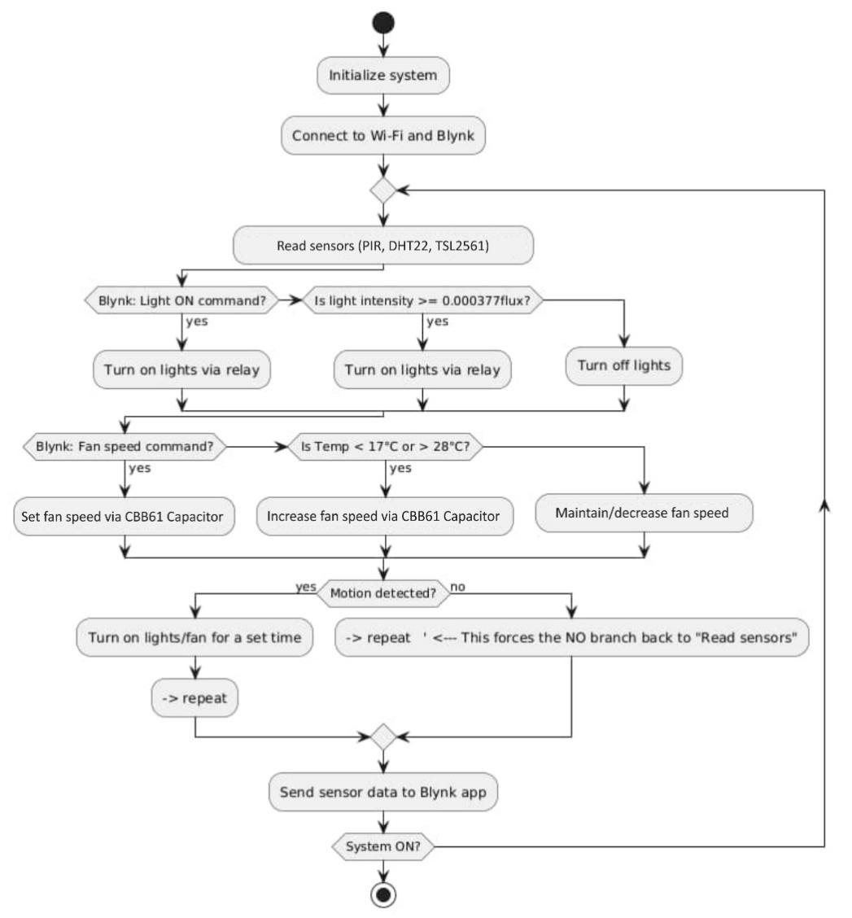
Figure 1: Flowchart

3.1.2 Block Diagram
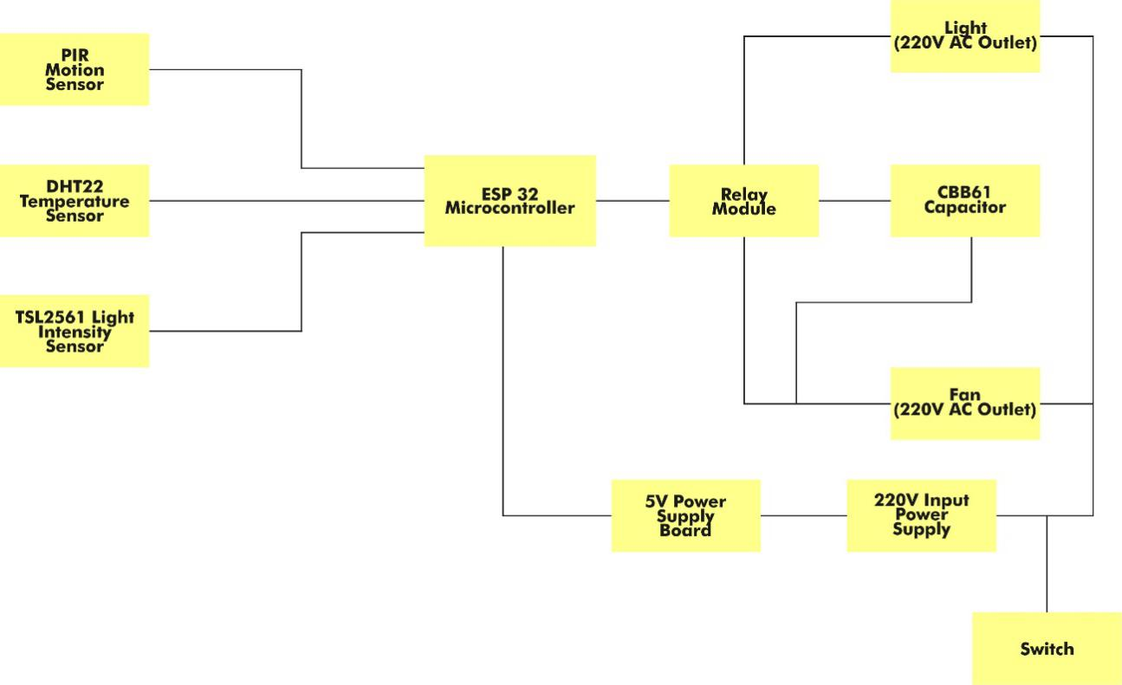
Figure 2: Block Diagram

3.1.3 Circuit Diagram
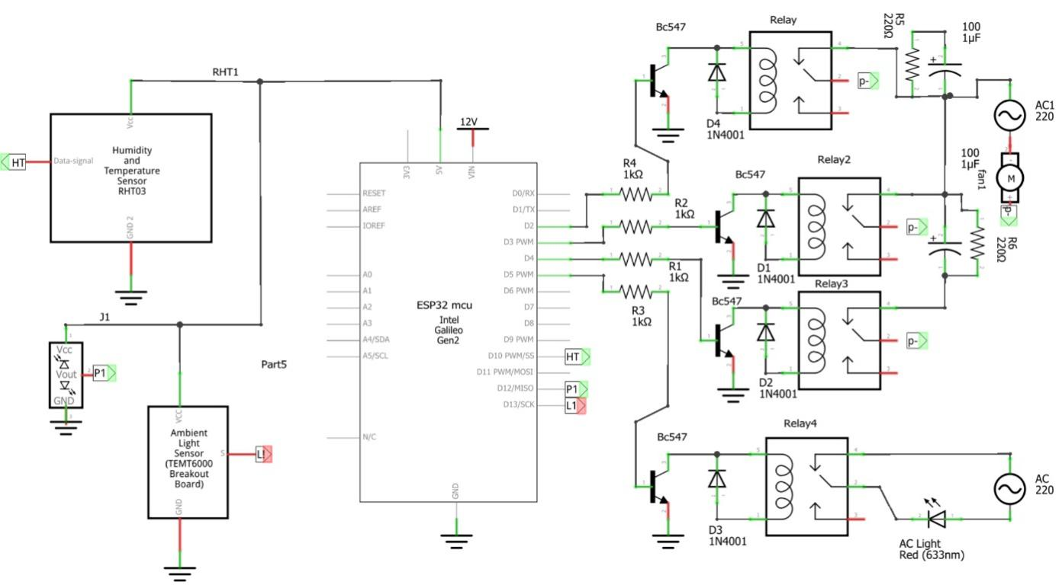
Figure 3: Circuit Diagram

3.2 Materials and Components

3.2.1 ESP32 Microcontroller
This the “brain” of the system. It receives data from sensors, executes the programming logic, controls the relays, and communicates with the IoT platform (Blynk). It has built-in- WiFi and Bluetooth capabilities, making it excellent for wireless IoT applications.
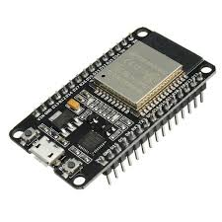
Plate 1: ESP32 Microcontroller [43]

3.2.2 TSL2561 Light Intensity Sensor
This sensor measures light levels (lux). It contains both infrared and full spectrum diodes, allowing it to approximate the human eye’s response. In this project, the TSL2561 light intensity sensor will detect when it gets dark and trigger the lights to turn on.
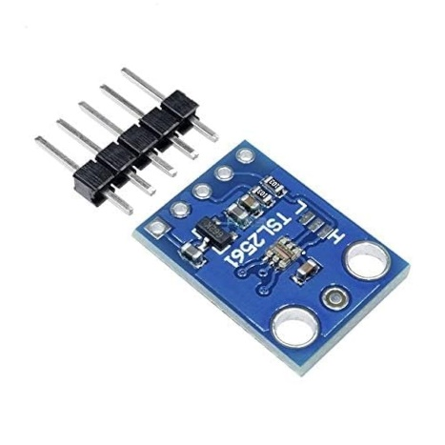
Plate 2: TSL2561 Light Intensity Sensor [44]

3.2.3 PIR Sensor (HC-SR501)
This is a passive infrared sensor that detects motion by sensing changes in infrared radiation emitted by objects in its field of view. It will turn on lights or fans when motion is detected.
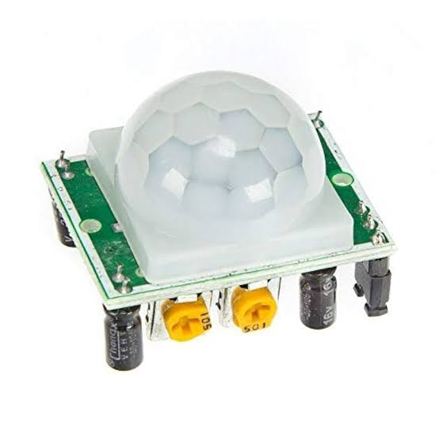
Plate 3: PIR Sensor (HC-SR501) [45]

3.2.4 DHT22 Sensor
This sensor measures both temperature and humidity. It uses a capacitive humidity sensor and a thermistor to measure the surrounding air. It detects room temperature as soon as it is powered ON and operate within temperature range of <17◦C to >28◦C to adjust the fan speed.
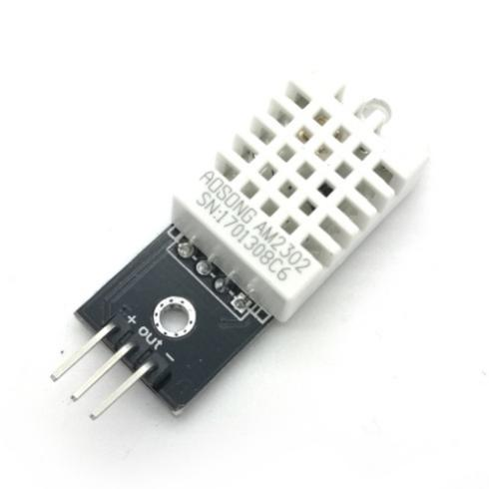
Plate 4: DHT22 Sensor [46]

3.2.5 Relay Module
A relay module acts like a switch to our electronic circuit that let users open or close it by transmitting a signal. It allows the low-power ESP32 to control the higher voltage circuits of the lights and fans. When the control signal is applied to the input side of the relay, it activates the electromagnet, which attracts an armature. This in turn closes the switch contacts on the output (high voltage) side, allowing electricity to flow and power the device or system that is connected to it. In this project, (a single channel and 4-channel) relay module was used.
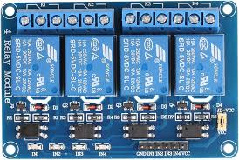
Plate 5: Relay Module [47]

3.2.6 CBB61 Capacitor
A CBB61 capacitor works by storing energy in an electric field. When a voltage is applied to the capacitor, it charges up and stores energy in the form of an electric field. This energy can then be released when the capacitor is discharged. It is primarily used as a motor run capacitor within single-phase AC motors. Its core purpose lies in generating the necessary phase shift in the alternating current, which is vital for initiating and sustaining the rotation of the motor. It’s used with AC motors, like those in fans, to help them start and run efficiently.
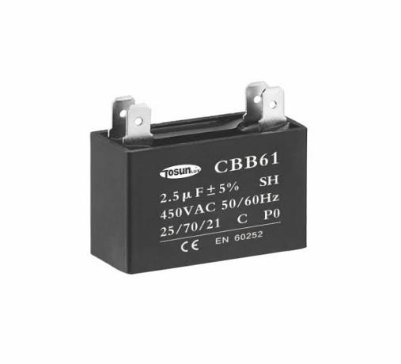
Plate 6: CBB61 Capacitor [48]

3.2.7 250V Capacitor
This is a general-purpose capacitor used for filtering or energy storage in the AC circuit.
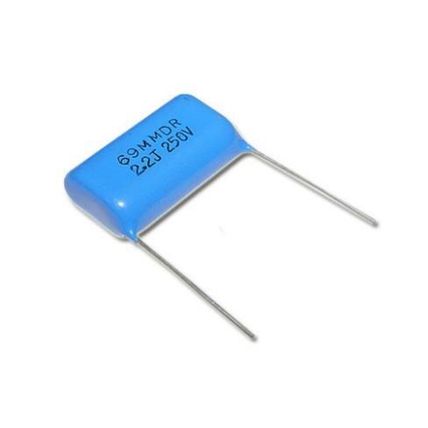
Plate 7: 250V Capacitor [49]

3.2.8 Resistors
Resistors restrict the flow of electric current in the circuit. They are used to create voltage dividers, limit current to LEDs, and provide pull-up or pull-down resistors for digital signals.
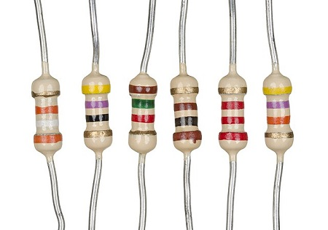
Plate 8: Resistors [50]

3.2.9 Switch
A switch is a device used to open or close an electrical circuit, to manually control the power supply to the system. It is used for turning the system on or off, providing a simple way to manage energy consumption. In this project, it will provide a manual override for the automated controls.
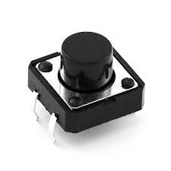
Plate 9: Switch [51]

3.2.10 220V Power Outlet
This is the standard AC power source in many regions. It provides the high voltage needed to power the lights and fans.
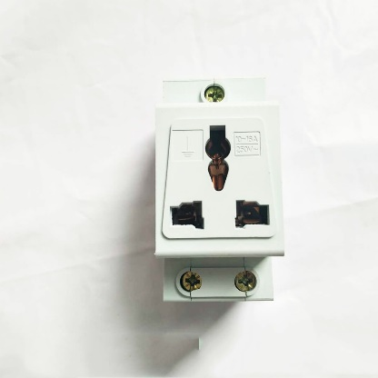
Plate 10: 220V Power Outlet [52]

3.2.11 5V Power Supply Board
A 5V power supply board is a circuit designed to provide a stable 5V DC (Direct Current) output voltage from an AC (Alternating Current) input or another DC voltage source. It converts the 220V AC power from the outlet to 5V DC power, which is needed to power the ESP32 and other low-voltage components.
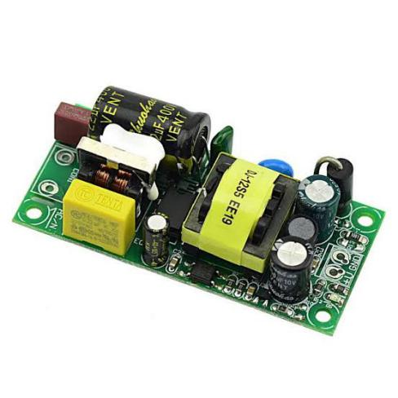
Plate 11: 5V Power Supply Board [53]

3.2.12 Power Cable
Power cable systems transmit electrical energy and typically include the following components, each serving a specific function: The conductor is the main transmission medium and carries current. The insulation surrounds the conductor to provide electrical isolation and prevent contact between the conductor and the surrounding environment. It connects the 220V power outlet to the 5V adapter.
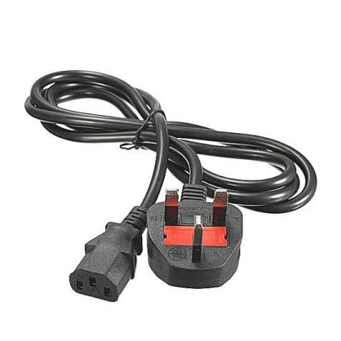
Plate 12: Power Cable [54]

3.2.13 Energy Bulb (LED Light Bulb)
Energy bulb serves as the primary lighting element. LED bulbs are energy-efficient, long-lasting, and can be controlled via the relay module connected to the ESP32. The system will switch the bulb on or off based on sensor readings (e.g., darkness detected by the TSL2561, or motion detected by the PIR sensor) or remote commands.
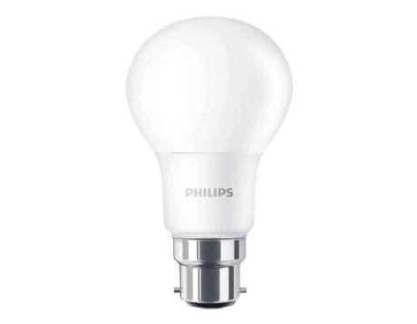
Plate 13: Energy Bulb (LED Light Bulb) [55]

3.2.14 AC Standing Fan
AC standing fan is a self-contained cooling device designed for indoor use. It typically consists of a bladed fan powered by an AC motor, mounted on an adjustable stand or pedestal for height customization. These fans are designed to circulate air within a room, creating a cooling effect through increased air movement and evaporation.
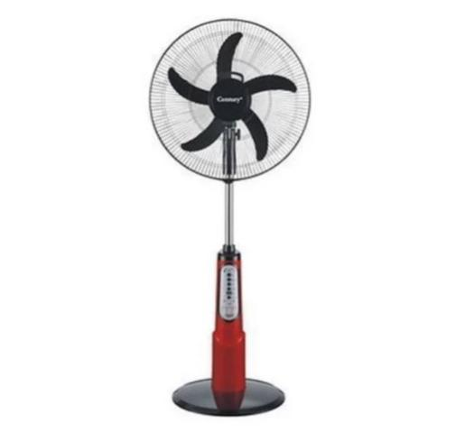
Plate 14: AC Standing Fan [56]

3.2.15 Breadboard
A solderless breadboard is a reusable platform with a grid of holes used to quickly build and test electronic circuits. It will be used for initial prototyping and testing of the sensor circuits and the ESP32 connections.
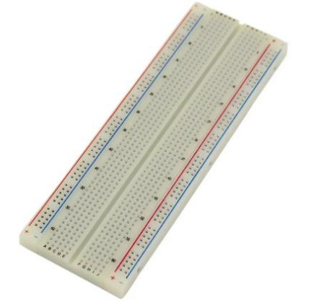
Plate 15: Breadboard [57]

3.2.16 Pattress Box
This is a plastic box that will house the major components and provide a safe enclosure for the mains voltage wiring.
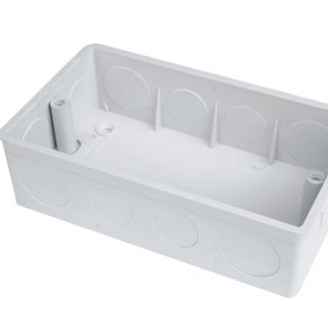
Plate 16: Pattress Box [58]

3.2.17 Jumper Wires
These are wires with connector pins at each end, used to connect components to the ESP32 microcontroller or on a breadboard. They allow you to create temporary connections without soldering.
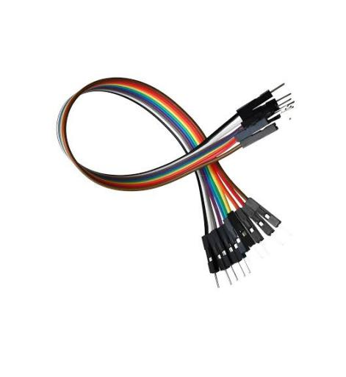
Plate 17: Jumper Wires [59]

3.2.18 Glue Sticks
Glue sticks can be used for temporarily securing wires or components in place, providing insulation, or for general-purpose adhesion in low-stress areas.

Plate 18: Glue Sticks [60]

3.2.19 Pin headers
These are short pins or terminals arranged in a plastic housing, used to connect wires and cables to circuit boards. They provide a convenient way to make detachable connections to the ESP32 and other modules.
Plate 19: Pin Headers [61]

3.2.20 Vero Board
This is a type of prototyping board with pre-drilled holes and parallel copper strips on one side. The ESP32 microcontroller and CBB61 capacitor is been soldered on the vero board.
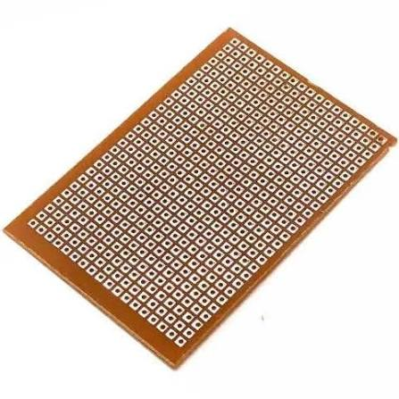
Plate 20: Vero Board [62]

3.2.21 Connectors
Connectors are devices that join electrical circuits, enabling the flow of electricity between devices. They can be male (plugs) or female (jacks or sockets). In this project, connectors will be used to connect the power supply, sensors, and other modules to the ESP32.
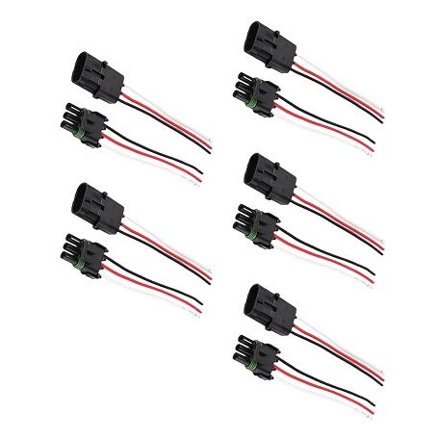
Plate 21: Connectors [63]

3.2.22 Solder
Solder is a metal alloy used to create a permanent electrical connection between electronic components. It melts at a relatively low temperature and, when cooled, forms a conductive bond that mechanically joins the components and allows electricity to flow between them. In this project, the solder is used to build a permanent circuit (CBB61 capacitor) on the Vero board or connecting wires directly to components.

Plate 22: Solder [64]

3.2.23 Electrical Tape
Electrical tape is a type of pressure-sensitive adhesive tape used to insulate electrical wires and other components that conduct electricity. It is typically made of vinyl or plastic and has a non-conductive adhesive. It is primarily used for insulation, protecting wires and connections from short circuits and electrical shock. In this project, electrical tape is used to insulate exposed wires and connections, especially those handling mains voltage (220V), to prevent short circuits and ensure safety.

Plate 23: Electrical Table [65]

3.3 Design Specifications

3.3.1 ESP32 Microcontroller Specifications
Processors | Xtensa dual-core (or single-core) 32-bit Lx6 microprocessor
Memory | 520 KiB RAM. 448 KiB ROM. RTC SRAM: 16 KB
Wireless Connectivity | Wi-Fi: 802.11b/g/n. Speeds up to 150Mbps.  Bluetooth: v4.2 Classic and BLE (Bluetooth Low Energy)
Peripheral Interfaces | 34 programmable GPIOs. 10 x touch sensors. Up to 18 channels of 12-bit SAR ADC. 2 channels of 8-bit DAC. 16 channels of LED PWM. Serial Connectivity: 2 x 12C, 4 x SPI, 3 x UART & 2 x I2S. Ethernet MAC (for physical LAN Communication)
Security | IEE 802.11 standard security features (WPA, WPA2, WPA3). Secure boot. Flash encryption
Power Management | Internal low-dropout regulator
Operating Temperature | -40◦C to +125◦C
Operating Voltage | 3.3v
Table 1: Specification of ESP32 Microcontroller used

3.3.2 TSL 2561 Light Intensity Sensor Specifications
Dynamic Range | 0.1 – 40, 000+ Lux
Interface | I2C digital interface
Supply Voltage | 2.7V to 3.6V
Maximum Supply Current | 0.6Ma
Operating Temperature Range | -30◦C to 80◦C
Spectral Response | Approximates human eye response
 | Contains both infrared and full spectrum diodes
 | I2C 7-bit addresses 0x39, 0x29, 0x49, selectable with jumpers
Table 2: Specification of TSL2561 Light Intensity Sensor used

3.3.3 PIR Sensor (HC-SR501) Specifications
Detection Range | Up to 7 meters
Detection Angle | Approximately 110◦C to 140◦C
Adjustable Delay Time | Ranging from 5 seconds to 300 seconds
Trigger Modes | Repeatable (H) mode for continuous detection and non-repeatable (L) mode for single-event triggers
Operating Voltage | 4.5V to 20V DC
Current Consumption | Less than 50Ua to 65Ua
Sensitivity | Adjustable
Table 3: Specification of PIR Sensor (HC-SR501) used

3.3.4 DHT22 Sensor Specifications
Operating Voltage | 3.3V to 5.5V
Operating Current | 0.3mA (measuring), 60Ua (standby)
Output | Serial data. Digital data via a single-bus interface
Temperature Range | -40◦C to 80◦C
Humidity Range | 0% to 100%
Resolution | Temperature and Humidity both are 16-bit. 0.1◦C for temperature and 0.1%RH for humidity
Accuracy | ±0.5°C and ±2%. Temperature Accuracy: ±0.5°C Humidity Accuracy: ±2%RH (25°C)
Sampling Rate | 0.5Hz (one reading every 2 seconds)
Table 4: Specification of DHT22 Sensor used

3.3.5 Relay Module (4-Channel and Single-Channel) Specifications
 | 4-Channel | Single-Channel
Number of Channels | 4 | 1
Supply Voltage | 3.75V to 6V DC | 3.75V to 6V DC
Input Trigger Current | 5mA
Quiescent Current |  | 2mA
Relay Operating Voltage | 3.3V to 5V DC | 3.3V to 5V DC
Current through coil (Relay Active) | ~300mA | ~70mA
Relay Max Contact Voltage | 250V AC /30V DC | 250V AC /30V DC
Relay Max Contact Current | 10A | 10A (NO), 5A (NC)
Input Control Signal | Active Low (typically) | Active Low (typically)
Dimensions | Typically around 75mm x 55mm x 18mm | Typically around 43mm x 17mm x 17mm
Pinout | VCC: Power supply for the module (3.75V to 6V DC). GND: Ground. IN1, IN2, IN3, IN4: Control signal inputs. COM (x4): Common terminal for each relay. NO (Normally Open) (x4) terminal. NC (Normally Closed) (x4) terminal. | VCC: Power supply for the module (3.75V to 6V DC). GND: Ground. IN: Control signal input. COM: Common terminal. NO (Normally Open) terminal. NC (Normally Closed) terminal.
Features | Opto-isolation (for protecting the microcontroller). LED indicator for relay status (ON/OFF). Screw terminals for easy wiring | LED indicator for relay status (ON/OFF). Screw terminals for easy wiring
Table 5: Specification of Relay Module (4-Channel and Single-Channel) used

3.3.6 CBB61 Capacitor Specifications
Designed | For motors of electric fan
Capacitance Range | 1.0uF to 20uF. 1~35µF
Capacitance Tolerance | +/-10% standard. ±5%, ±10%, ±15%
Voltage Range | 250VAC, 370VAC, 440VAC, 450VAC. 110VAC to 600VAC (50/60Hz)
Dissipation factor | Low DF
Plastic box | Flame retardant plastic box (PBT)
Operating Frequency | 50/60Hz
Operating Temperature | -40°C to +105°C
Type | Metalized Polypropylene Film
Table 6: Specification of CBB61 Capacitor used

3.3.7 250V Capacitor Specifications
Type | Metalized Polyester Film Capacitor
Voltage Rating | 250V AC
Capacitance | 1.5uF, 3.3uF, 4.7Uf, 2.2uF, 0.068uF
Tolerance | ±5%, ±10% (common)
Lead Type | Radial or Axial (Through Hole)
Operating Temperature | -40°C to +85°C or +100°C
Table 7: Specification of 250V Capacitor used

3.3.8 220V AC Power Outlet Specifications
Voltage Rating | 220V – 240 V AC
Current Rating | 15A, 20A, 30A, 50A
Wiring | Three-wire (Hot, Hot, Ground). Four-wire (Hot, Hot, Neutral, Ground)
NEMA Standards | 6-15, 6-20, 6-50, 10-30, 14-30, 14-50
Safety | Grounded for safety
Table 8: Specification of 220V AC Power Outlet used

3.3.9 5V Power Supply Board Specifications
Input Voltage | 220V AC or a range of DC voltages
Output Voltage | 5V DC (regulated)
Output Current | 600mA, 1A, 2A, or higher
Wattage | The power supply can provide (Volts x Amps)
Table 9: Specification of 5V Power Supply Board used

3.4 Tools and Software
In assembly the components together, various tools and software were used. They are listed below with their functions.
- Soldering Iron: A soldering iron is a hand tool used to melt solder, a metal alloy, to join two or more metal parts together. It's essential for creating permanent electrical connections in electronics projects, such as soldering components to a Vero board or connecting wires. The tip of the iron heats up to a high temperature, allowing you to melt the solder and create a strong, conductive bond.
- Wire strippers/cutters: These are multi-purpose tools designed to both cut and strip the insulation from electrical wires. Wire strippers have notches or adjustable blades to remove the outer jacket of a wire without damaging the conductor. Wire cutters have sharp edges to cleanly cut wires. Using the correct wire stripper for the gauge of wire is important to avoid damaging the wire.
- Multi-meter: A multi-meter is a versatile electronic measuring instrument used to measure voltage, current, and resistance. It's an indispensable tool for diagnosing and troubleshooting electrical circuits and electronic devices. It can be used to check for continuity and identify faulty components.
- Helping Hands: This tool, also known as a third hand, is an adjustable jig used to hold materials steady during tasks like soldering, gluing, or repair work. It typically consists of a weighted base and adjustable arms with crocodile clips to hold small objects in place, freeing up your hands to work.
- Screwdrivers: A screwdriver is a hand tool used for turning screws to fasten or loosen them. Various sizes and types (e.g., Phillips head, flat head) are used to assemble the system enclosure, connect wires to terminal blocks, and mount components.
- Pliers: Pliers are hand tools used for gripping, bending, and cutting a wide range of materials. They provide leverage to multiply the strength of your hand. Different types of pliers are available for specific tasks, such as gripping round objects, twisting wires, or cutting wires.
- Computer/Laptop: A computer or laptop is essential for writing, compiling, and uploading code to the ESP32 microcontroller. It is needed to run the Arduino IDE (or an alternative development environment) and to interface with the IoT platform.
- IoT Platform (Blynk): Blynk is a low-code IoT platform that allows you to build mobile apps to control and monitor your devices. It offers a drag-and-drop interface for creating user interfaces and supports various hardware platforms, including ESP32.
- Programming Software (Arduino IDE): Arduino IDE with ESP32 core is a user-friendly, open-source integrated development environment (IDE) widely used for programming microcontrollers.

3.5 Experimental Setup/Assembly Process

3.5.1 Software Setup
- Install Arduino IDE: Download and install the Arduino IDE from the official website.
- Add ESP32 Board Support: Add the ESP32 board support to the Arduino IDE. Go to File > Preferences, add the ESP32 board URL to "Additional Board Manager URLs". Then, go to Tools > Board > Board Manager, search for ESP32, and install the package.
- Install Libraries: Install necessary libraries via the Arduino IDE Library Manager. Search for and install libraries for: DHT22 (Adafruit DHT Sensor Library) and TSL2561

3.5.2 Wiring & Connections
- ESP32 to Relay Module:
- Connect the VCC pin of the relay module to the 5V pin on the ESP32.
- Connect the GND pin of the relay module to the GND pin on the ESP32.
- Connect the signal pins (IN1, IN2, IN3, IN4) of the relay module to digital output pins on the ESP32 (GPIO 26, GPIO 27, GPIO 14, GPIO 12).
- ESP32 to DHT22:
- Connect the VCC pin of the DHT22 to the 5V pin on the ESP32.
- Connect the GND pin of the DHT22 to the GND pin on the ESP32.
- Connect the DATA pin of the DHT22 to a digital GPIO pin on the ESP32 (GPIO 4). Include a 10k Ohm pull-up resistor between the DATA and VCC lines.
- ESP32 to TSL2561:
- Connect the VCC pin of the TSL2561 to the 5V pin on the ESP32.
- Connect the GND pin of the TSL2561 to the GND pin on the ESP32.
- Connect the SCL pin of the TSL2561 to the SCL pin on the ESP32 (GPIO 22).
- Connect the SDA pin of the TSL2561 to the SDA pin on the ESP32 (GPIO 21)
- ESP32 to PIR Sensor:
- Connect the VCC pin of the PIR sensor to the 5V pin on the ESP32.
- Connect the GND pin of the PIR sensor to the GND pin on the ESP32.
- Connect the OUT pin of the PIR sensor to a digital GPIO pin on the ESP32 (GPIO 13)
- Relay Module to Lights and Fans: (Important: Use extreme caution when working with mains voltage.)
- Connect the NO (Normally Open) terminal of the relay to the phase (live) wire of the 220V power outlet.
- Connect the COM (Common) terminal of the relay to the phase (live) wire of the light or fan.
- Connect the neutral wire of the light/fan directly to the neutral wire of the 220V power outlet
- Connect the ground wires appropriately.
- CBB61 Capacitor and Fan Speed:
- The CBB61 capacitor is used in some AC induction fan motors for starting and running. Its value is critical and specific to the fan motor. Incorrect values can damage the motor or prevent it from running.
- If you plan to control fan speed, you'll likely need a more sophisticated approach than simply switching the capacitor in/out. Consider using a TRIAC-based fan speed controller, which must be properly rated for the voltage and current. Control the TRIAC with a PWM output from the ESP32 (with appropriate isolation circuitry).

3.5.3 Code Development
- Basic Code Structure:
- Include necessary libraries.
- Define GPIO pins for each sensor and relay.
- Initialize serial communication.
- Initialize sensors.
- Sensor Reading Functions:
- Create functions to read data from each sensor (DHT22, TSL2561, PIR).
- Convert sensor data to appropriate units (Celsius & Lux).
- Control Logic:
- Implement logic to control lights and fans based on sensor data and user preferences. Example: If (TSL2561 reading < threshold) turn on lights.
Example: If (DHT22 temperature > threshold) increase fan speed.
Example: If (PIR sensor detects motion) turn on lights for a set duration.
- Implement manual override using the switch.
- Relay Control Functions:
- Create functions to turn on/off relays connected to lights and fans.

3.5.4 IoT Platform Integration
- Choose an IoT platform (Blynk).
- Connect the ESP32 to your Wi-Fi network.
- Use the platform's libraries or APIs to send sensor data to the cloud and receive control commands from the mobile app/web interface.
- Testing and Iteration:
- Upload the code to the ESP32.
- Monitor sensor readings and relay states via the serial monitor.
- Test remote control functionality via the mobile app/web interface.
- Calibrate sensors and adjust thresholds as needed.
- Refine control logic and user interface based on testing.

3.5.5 Important Considerations
- Safety: Mains voltage (220V) is dangerous. Take extreme care when wiring relays to control lights and fans.
- Component Compatibility: Ensure all components are compatible with the ESP32's voltage levels (5V). Use level shifters if necessary.
- Power Supply: Provide a stable 5V power supply for the ESP32 and relay module.
- IoT Platform Selection: Choose Blynk IoT platform which meets our needs in terms of features, pricing, and ease of use.
- Enclosure: Consider an enclosure to protect the electronics and prevent accidental contact with mains voltage.
- Fan Speed Control: CBB61 capacitors are for specific AC fan motors. Do not use them without confirming they are the correct rating for the fan motor. Consider TRIAC-based controllers for safe and effective speed control.
- Code Structure: Organize our code into functions for readability and maintainability.

CHAPTER FOUR

RESULTS AND DISCUSSION

4.1 Prototype Development

4.1.1 Description of the Final Prototype
The final prototype consisted of an ESP32 microcontroller acting as the central controller. This was connected to a TSL2561 light intensity sensor (placed by the side of the pattress box), a DHT22 temperature and humidity sensor and a PIR motion sensor which is placed on top of the pattress box. A 4-channel relay module was used to switch the connected devices (an LED bulb representing a light, and a small DC fan). All components were initially connected on a breadboard for ease of experimentation, before the ESP32 microcontroller and CBB61 capacitor is being transferred to Vero board for a more permanent and robust assembly. The entire assembly was then housed within a plastic pattress box to ensure electrical safety and a tidy appearance.
The software was developed using the Arduino IDE, leveraging the ESP32 core for microcontroller-specific functions. Key software modules included: sensor reading (handling data acquisition from the DHT22, TSL2561, and PIR sensors), control logic (implementing the automation rules based on sensor data), relay control (managing the switching of the relay module), and Wi-Fi communication (enabling connectivity to the Blynk IoT platform).
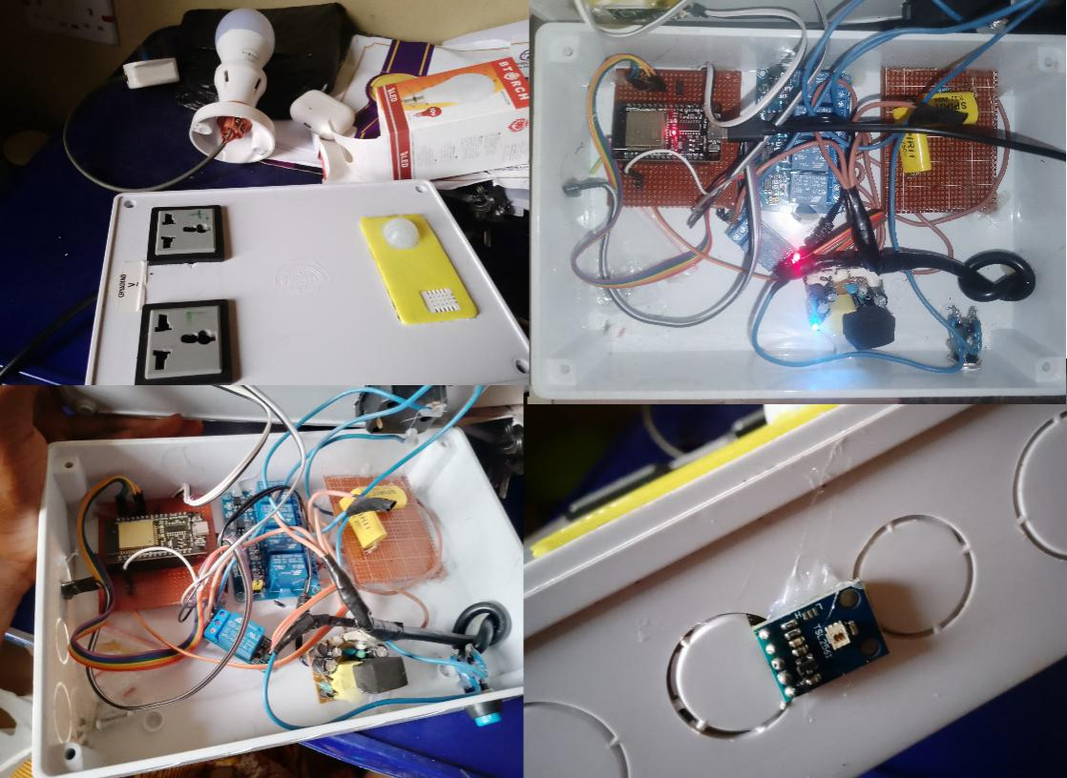
Plate 24: Photo of the Assembled Prototype
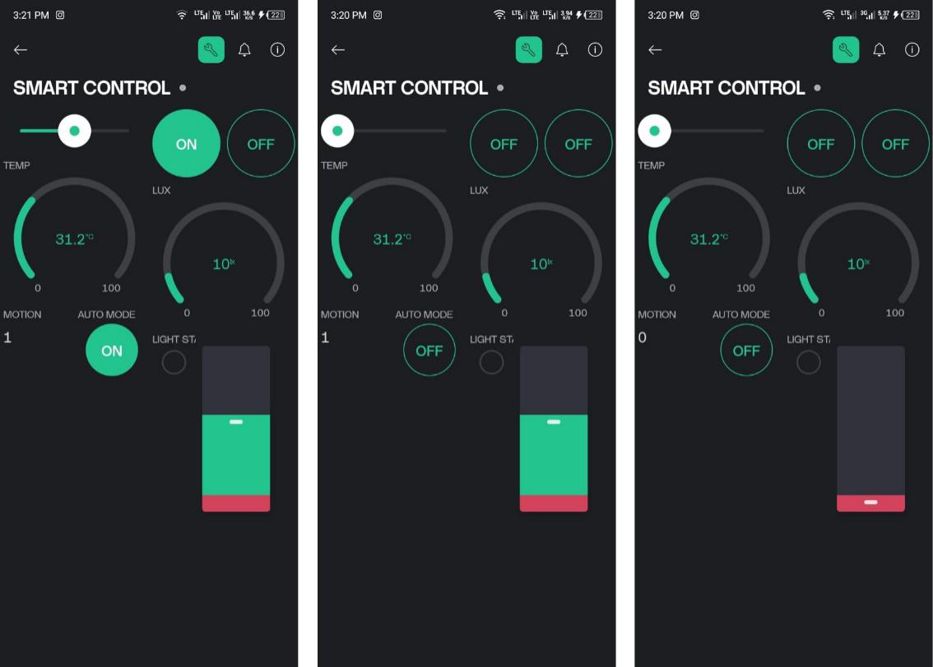
Plate 25: Blynk IoT Interface

4.1.2 Development Process Summary
The development process began with individual testing of each sensor and actuator (CBB61 capacitor, single & 4-channel relay module, 250V capacitors, resistors, and switch) to ensure correct functionality. Once each component was verified, they were integrated on the breadboard to test the basic control logic. Several iterations were performed to refine the sensor thresholds and control algorithms. The final step involved transferring the working circuit to a Vero board, soldering all connections, and encasing the assembly in the pattress box.
A significant design change involved the selection of the CBB61 capacitor to start and adjust the fan speed like TRIAC phase controller, because of the circuitry to work on its own. Also, selection of the DHT22 sensor over a DHT11. The DHT22 offered a wide operating range and higher accuracy, which was deemed necessary for reliable temperature and humidity monitoring.

4.2 Testing Procedures
Testing was conducted by creating specific scenarios and observing the system’s response.

4.2.1 Description of Test Scenarios
- Remote Control: The ability to remotely turn the LED bulb and fan on/off via a Blynk web interface was tested.
- Automated Control (Light Intensity): The system’s ability to automatically turn on the LED bulb when the TSL2561 sensor detected a light level below a pre-determined threshold (e.g., 50 lux) was tested.
- Automated Control (Temperature): The system’s ability to automatically turn on the fan when the DHT22 sensor detected a temperature above 28◦C was tested.
- Automated Control (Motion Detection): The system’s ability to turn on the LED bulb for 10 seconds when motion was detected by the PIR sensor was tested.
- Scheduled Control: It was tested by specific on/off times and verifying that the lights turned on/off accordingly.

4.2.2 Testing Methodology
- For remote control testing, the web interface (Blynk) was used to send on/off commands to the ESP32, and the corresponding state of the LED bulb and fan were visually verified. A multimeter was used to confirm the relay module’s switching action.
- For automated light intensity control, the TSL2561 sensor was covered to simulate darkness, and the system’s response (turning on the LED bulb) was observed. A light meter was used to verify the light level at which the bulb turned on.
- For automated temperature control, the DHT22 sensor was subjected to varying temperatures (using a heat gun), and the system’s response (turning on the fan) was observed. A thermometer was used to verify the temperature at which the fan turned on.
- For automated motion detection, motion was introduced in front of the PIR sensor, and the system’s response (turning on the LED bulb) was observed.

4.3 Results

4.3.1 Presentation of data
- Remote Control: The remote control functionality was assessed by measuring the response time between sending a command from the web interface (Blynk IoT platform) and the corresponding action (turning the light or fan on/off) occurring. The average response time was 0.85 seconds, with a standard deviation of 0.2125 seconds over 20 trials. A table summarizing the response times for different commands (light on, light off, fan on, fan off) is shown below:
Table 12: A table summarizing the response times for different commands
Command | Average Response Time (s) | Standard deviation (s)
Light on | 0.8 | 0.2
Light off | 0.8 | 0.2
Fan on | 1.0 | 0.25
Fan off | 0.8 | 0.2

- Automated Control (Light Intensity): The automated light intensity control was tested by measuring the light level at which the LED bulb turned on. The average turn-on light level was 48 lux, with a range of 45-52 lux.
- Automated Control (Temperature): The automated temperature control was tested by measuring the temperature at which the fan turned on. The average turn-on temperature was 28◦C, with a range of 25◦C - 28◦C.
- Automated Control (Motion Detection): The motion detection functionality was tested by measuring the response time between detecting motion and the LED bulb turning on. The average response time was 0.8 seconds, with a standard deviation of 0.2 seconds. The reliability of the motion detection was also assessed by counting the number of false positives (turning on the light when no motion was present) over a 24-hour period. The number of false positives was 2.

4.3.2 Key Findings
- The remote control functionality demonstrated good responsiveness, with average response times consistently below 1 second.
- The automated light intensity and temperature control functions were accurate in triggering the corresponding actions at the pre-defined thresholds.
- The motion detection functionality was generally reliable, but a small number of false positives were observed.

4.4 Discussion
Building this smart home automation system to control lights and fans opens up a lot of interesting questions about how well it works and what could be done better. We looked at things like:
- Making sure you can control things easily from your phone: It needs to be quick when you press a button, and it needs to work reliably. That means the web interface, the internet connection, the microcontroller, and sensors inside all need to be fast and dependable.
- Making the system smart enough to do things on its own: We want the lights to turn on automatically when it gets dark, and the fan to adjust on the room temperature. To do that right, the sensors need to be accurate, and the system needs to adjust itself over time.
- Saving energy: Smart homes should save you money on your electricity bill. We need to use parts that don't use much power, and we need to turn things off when they're not needed.
- Keeping your home safe from hackers: This is a big one. We need to make sure no one can break into your system and mess with your lights or, even worse, steal your personal information.
- Making it easy to add more appliances later: If you want to add more lights, or a smart thermostat, it should be easy to do. The system should be designed to work with lots of different devices.
- Making it easy to use: No one wants a smart home that's confusing and frustrating. The app should be simple and easy to understand.
- Keeping the cost down: Smart home components can be expensive. Using affordable parts and free software to keep the price reasonable.
Looking ahead, there are some really cool things we could do with this system:
- Use artificial intelligence to make it even smarter: The system could learn your habits and automatically adjust the lights and temperature to your liking.
- Use cameras and voice control to make it even easier to use: Imagine just telling your lights to turn on, or having the system recognize you and automatically adjust the settings to your preferences.
- Make it even more secure and reliable: We could use new technologies to protect your system from hackers and make sure it always works, even when the power goes out.
- Make it more sustainable: We could connect the system to solar panels or other renewable energy sources to reduce your carbon footprint.
Overall, this project shows that it's possible to build your own smart home system without spending a fortune. But there's always room for improvement. By focusing on making the system faster, more accurate, more secure, more user-friendly, and more sustainable, we can create smart homes that are truly intelligent and beneficial.

4.4.1 Comparison with objectives
The project successfully achieved its primary objectives of creating a smart home automation system capable of remotely and automatically controlling lights and fans. The system demonstrated reliable remote control functionality and accurate automated control based on environmental conditions.
However, the temperature-based fan control exhibited a slightly slower response time than initially anticipated, which could be improved with further optimization of the control algorithm.

4.4.2 Challenges and troubleshooting
One of the main challenges encountered was ensuring reliable Wi-Fi connectivity for the ESP32, particularly in areas with a weaker signal. This issue was resolved by updating the ESP32 core and IoT platform library to the latest versions.

CHAPTER FIVE

CONCLUSION

5.1 Conclusion
In summary, this project created a smart home automation system that allows you to control lights and fans remotely using a microcontroller and the Blynk IoT platform. You can manage these devices through a web interface, and they can also operate automatically based on sensor readings and preset schedules. This shows how integrating Internet of Things (IoT) technology can improve home life by making it more convenient and efficient.
The system can turn on lights when it gets dark, adjust fan speeds based on temperature, and activate lights or fans when it detects motion, enhancing comfort, energy savings, and security in your home. Its design is flexible and can be expanded in the future to include more smart devices.

Contribution to Knowledge
This project offers a practical example of how to build a complete smart home system, detailing both the hardware and software involved. It serves as a helpful reference for students, hobbyists, and researchers interested in creating similar setups.
By successfully integrating the ESP32 microcontroller with the Blynk IoT platform, the project demonstrates a cost-effective way to build smart home systems, making them accessible to more people.
The system allows users to customize how it reacts to different conditions using sensors for light, temperature, and motion. This personalization makes it easier for the system to adapt to individual preferences.
By automating lighting and fan controls, the project shows how smart home technology can save energy and increase convenience. The system's ability to adjust automatically reduces waste and makes life easier.
Additionally, the project uses affordable, readily available components, keeping the cost down while still providing a rich set of features.

5.3 Recommendations
Based on the project's findings and current trends in smart home technology, here are some suggestions for future improvements:
- Use Better Sensors: Incorporate the LD2410 mmWave radar sensor for more accurate presence detection. This sensor can differentiate between humans and pets, reducing false alarms.
- Enhance Security: Implement stronger security measures to protect against unauthorized access. This includes using strong passwords and encryption, and possibly adding two-factor authentication.
- Voice Control: Add compatibility with voice assistants like Amazon Alexa or Google Assistant for hands-free control, making it easier for everyone, including those with disabilities.
- More Sensors and Data Analysis: Include additional sensors (like air quality and humidity) and use data analytics to improve system performance and provide useful insights to users.
- Mobile App Development: Create a user-friendly mobile app for easy configuration and control. The app should give real-time updates and allow users to customize settings.
- Broader Device Compatibility: Ensure the system can work with more smart devices and appliances, allowing seamless integration into users' existing setups.
- AI and Machine Learning: Integrate AI and machine learning to make the system smarter. It can learn user habits and optimize performance based on real-time data.
- Focus on Energy Efficiency: Design the system for energy savings and sustainability. Use energy-efficient components and consider renewable energy sources like solar power.
- Interoperability: Improve how different smart devices work together by adopting open standards. This will enhance user experience and encourage more people to adopt smart home technology.
- Explore Blockchain for Security: Consider using blockchain technology to enhance security and privacy, protecting user data and device communication.
By following these recommendations, future developments can further improve smart home automation systems, making them an essential part of modern living.

REFERENCES
[1] M. A. Hoque and C. Davidson, “Design and Implementation of an IoT-Based Smart Home Security System,” International Journal of Networked and Distributed Computing, vol. 7, no. 2, pp. 85–92, Apr. 2019, doi: 10.2991/ijndc.k.190326.004.
[2] I. Mumba et al., “Smart Home Automation: Integrating Voice and Typed Command Control for Lights, Fan, and Socket, with Automated Water Tank Management and Room Temperature Sensing,” International Journal of Advanced Multidisciplinary Research and Studies, vol. 5, no. 4, pp. 995–1002, 2025.
[3] A. S. Imam et al., “Design of an ESP32-Based IoT Smart Home Automation Management System,” Global Journal of Research in Engineering & Computer Sciences, vol. 4, no. 4, pp. 121–130, Aug. 2024, doi: 10.5281/zenodo.13334218.
[4] S. A. Jabbar et al., “Design and Implementation of IoT-Based Automation System for Smart Home,” Conference Paper, Nov. 2018, doi: 10.1109/ISNCC.2018.8531006.
[5] A. Suraj et al., “IoT Based Smart Home Automation Management System,” ASEAN Engineering Journal, vol. 9, no. 2, 2019.
[6] M. A. Hoque et al., “Design of Smart Home Automation System Using IoT,” International Journal of Engineering Research & Technology, vol. 10, no. 6, pp. 1–4, 2021.
[7] A. S. Ahmad et al., “Smart Home Automation and Security System Design Based on IoT Applications,” ASEAN Engineering Journal, vol. 9, no. 2, pp. 57–68, 2019.
[8] T. Rakhshan et al., “Intelligent Home Automation Systems: A Review,” Smart Science, vol. 8, no. 2, pp. 89–102, 2020.
[9] J. C. Mupala et al., “Voice-Controlled Home Automation System Using Natural Language Processing and IoT,” International Journal of Advanced Multidisciplinary Research and Studies, 2024.
[10] A. P. Gupta and J. Chhabra, “IoT Based Smart Home Design Using Power and Security Management,” International Conference on Innovation and Challenges in Cyber Security, 2016.

[11] A. K. Jain and R. Singh, “Home Automation Using Flutter and IoT,” Journal of Emerging Technologies and Innovative Research, vol. 7, no. 4, pp. 202–207, 2020.
[12] A. R. Behera et al., “A Comparative Study and Implementation of Real-Time Home Automation System,” International Conference on Energy Systems and Applications, 2015.
[13] R. Piyare and M. Tazil, “Bluetooth Based Home Automation System Using Cell Phone,” IEEE 15th International Symposium on Consumer Electronics, 2011.
[14] P. Gupta and J. Chhabra, “Smart Home Automation: A Review of Recent Developments and Future Prospects,” International Journal of Engineering and Advanced Technology, vol. 9, no. 4, pp. 763–766, 2020.
[15] E. N. Yilmaz et al., “Smart Home Automation: A Systematic Literature Review,” Journal of Ambient Intelligence and Humanized Computing, 2021.
[16] S. A. Jabbar et al., “Design and Fabrication of Smart Home with Internet of Things Enabled Automation System,” Journal of Engineering for Development, vol. 16, no. 4, pp. 40–54, 2024.
[17] Satyendra, R. et al., "Smart energy-efficient home automation system using IoT," International Journal of Engineering Research & Technology, vol. 9, no. 6, pp. 1-6, 2020.
[18] Tui-Yi, Y. et al., "Energy management algorithm for home automation system," International Journal of Energy Management, vol. 47, pp. 1-10, 2019.
[19] Mumba, I. and Mupala, J. C., "Smart Home Automation: Integrating Voice and Typed Command Control," in International Journal of Advanced Multidisciplinary Research and Studies, vol. 5, no. 4, 2025.
[20] Adeyemo, K. and Ayo, A., "Smart home technologies in Africa: A review," International Journal of Computer Sciences and Engineering, vol. 8, no. 9, pp. 440-446, 2019.
[21] Churasia, T. and Jain, P. K., "Model to reduce computation overhead in smart home solutions," International Journal of Advanced Research in Electrical, Electronics and Instrumentation Engineering, vol. 8, no. 3, pp. 1-8, 2019.
[22] Hoque, M. A. and Davidson, C., "Design and Implementation of an IoT-Based Smart Home Security System," International Journal of Networked and Distributed Computing, vol. 7, no. 2, pp. 85-92, 2019.
[23] Kumar, S. and Raj, E. G., "Smart home automation using ESP32 and cloud computing," International Journal of Engineering Research & Technology, vol. 10, no. 6, pp. 1-4, 2021.
[24] Al-Fuqaha, A. et al., "Internet of Things: A survey on enabling technologies, protocols, and applications," IEEE Communications Surveys & Tutorials, vol. 17, no. 4, pp. 2347-2376, 2015.
[25] Mumba, I., and Mupala, J. C. "Smart Home Automation: Integrating Voice and Typed Command Control," International Journal of Advanced Multidisciplinary Research and Studies, vol. 5, no. 4, pp. 995-1002, 2025.
[26] Gupta, A., and Chhabra, A. "Smart Home System: A Comprehensive Review." In 2016 IEEE International Conference on Automation Science and Engineering (CASE), pp. 727-732, August 2016.
[27] Behera, A., et al. "Design of a Real-Time Smart Home Automation System Using Arduino and Wi-Fi Technology." In 2015 International Conference on Robotics, Automation, Control and Embedded Systems (RACE), pp. 1-9, Chennai, 2015.
[28] Piyare, R., and Tazil, M. "Bluetooth Based Home Automation System Using Cell Phone." In 2011 IEEE 15th International Symposium on Consumer Electronics (ISCE), pp. 192-195, Singapore, June 2011.
[29] Suraj, S.; Agrawal, A.; Patil, K.; Kalamkar, V. Visual Machine Intelligence for Home Automation. In Proceedings of the 2020 IEEE International Conference on Electronics, Computing and Communication Technologies (CONECCT); Bangalore, India, 2–4 July 2020.
[30] M. A. Hoque and C. Davidson, “Design and Implementation of an IoT-Based Smart Home Security System,” Int. J. Networked Distributed Comput., vol. 7, no. 2, pp. 85–92, Apr. 2019.
[31] I. Mumba et al., “Smart Home Automation: Integrating Voice and Typed Command Control for Lights, Fan, and Socket, with Automated Water Tank Management and Room Temperature Sensing,” Int. j. adv. multidisc. res. stud., vol. 5, no. 4, pp. 995–1002, 2025.
[32] A. S. Imam et al., “Design of an ESP32-Based IoT Smart Home Automation Management System,” Global J. Res. Eng. Comput. Sci., vol. 4, no. 4, pp. 121–130, Aug. 2024.
[33] A. K. Jain and R. Singh, “Home Automation Using Flutter and IoT,” J. Emerg. Technol. Innov. Res., vol. 7, no. 4, pp. 202–207, 2020.
[34] S. Satyendra et al., “Smart Energy-Efficient Home Automation System Using IoT,” Int. J. Eng. Adv. Technol., vol. 9, no. 4, pp. 763–766, 2020.
[35] E. N. Yilmaz et al., “Smart Home Automation: A Systematic Literature Review,” J. Ambient Intell. Humaniz. Comput., 2021.
[36] T. Rakhshan et al., “Intelligent Home Automation Systems: A Review,” Smart Science, vol. 8, no. 2, pp. 89–102, 2020.
[37] A. R. Behera et al., “A Comparative Study and Implementation of Real-Time Home Automation System,” Int. Conf. Energy Syst. Appl., 2015.
[38] A. K. Kandekar and N. Shah, “Smart Home Automation: A Review,” Int. J. Eng. Res. Adv. Technol., vol. 5, no. 6, pp. 38–44, 2019.
[39] M. A. Hoque et al., “Design of Smart Home Automation System Using IoT,” Int. J. Eng. Res. Technol., vol. 10, no. 6, pp. 1–4, 2021.
[40] A. Suraj et al., “IoT Based Smart Home Automation Management System,” ASEAN Eng. J., vol. 9, no. 2, 2019.
[41] S. A. Jabbar et al., “Design and Implementation of IoT-Based Automation System for Smart Home,” Conf. Paper, Nov. 2018.
[42] J. C. Mupala et al., “Voice-Controlled Home Automation System Using Natural Language Processing and IoT,” Int. J. Adv. Multidisc. Res. Stud., 2024.
[43] "ESP32 Development Board (WiFi + Bluetooth)," Nerdshed. [Online]. Available: https://nerdshed.com.ng/product/esp32-development-board-wifi-bluetooth/. [Accessed: Oct. 3, 2025].
[44] TSL2561 Luminosity Breakout. [Online]. Available: https://www.amazon.in/TSL2561-Luminosity-Breakout-Infrared-Integrating/dp/B0DC5B1SZJ#. [Accessed: Oct. 3, 2025].
[45] Core Technologies HC-SR501. [Online]. Available: https://www.amazon.in/Core-Technologies-HC-SR501-Pyroelectric-Infrared/dp/B07DWGXN1G#. [Accessed: Oct. 3, 2025].
[46] DHT22 Temperature and Relative Humidity Sensor Module. [Online]. Available: https://www.makerstore.com.au/product/elec-sensor-dht22cable/?srsltid=AfmBOopcttPW1r5d5Zkhsxj3th5Uf2WzYpN8YZw6A8n_eiezj29C6mXI. [Accessed: Oct. 3, 2025].
[47] "4 Channel DC 5V Relay Module for Arduino Raspberry Pi DSP AVR PIC ARM," Ubuy. [Online]. Available: https://www.u-buy.com.ng/product/CK0AJEQ-jbtek-4-channel-dc-5v-relay-module-for-arduino-raspberry-pi-dsp-avr-pic-arm. [Accessed: Oct. 3, 2025].
[48] Tosunlux. “CBB61 Fan Capacitor,” [Online]. Available: https://www.tosunlux.eu/products/cbb61-fan-capacitor/. [Accessed: Oct. 3, 2025].
[49] Tedss. “Product 2020001024,” [Online]. Available: https://www.tedss.com/2020001024?srsltid=AfmBOoqGF9ng8BsZbbvqTi1JGfCBKk8nfCj_t3_6hQq_HJDrMrzdb3Nl. [Accessed: Oct. 3, 2025].
[50] Study.com. “What is a Resistor? Definition & Uses,” [Online]. Available: https://study.com/academy/lesson/what-is-a-resistor-definition-uses.html. [Accessed: Oct. 3, 2025].
[51] "Tact switch 12*12*6," HUB360. [Online]. Available: https://hub360.com.ng/product/tact-switch-12126/. [Accessed: Oct. 3, 2025].
[52] "AC30 250V 10A 16A 3 Plug," Alibaba. [Online]. Available: https://www.alibaba.com/product-detail/Ac30-250v-10a-16a-3-plug_1601286772883.html. [Accessed: Oct. 3, 2025].
[53] IndiaMart. “5V Power Supply Board,” [Online]. Available: `https://www.indiamart.com/proddetail/5v-power-supply-board-21685500691.html?srsltid=AfmBOopjuhZ4XK5ca1aSi33_6dTSSwMQxRecC9b32iYx6ZQuHBSk4gqK. [Accessed: Oct. 3, 2025].
[54] Kariakoo. “Power Cord Cable Fuse for PC,” [Online]. Available: https://mykariakoo.co.tz/products/power-cord-cable-fuse-pc-computer-monitor-3-pin-uk. [Accessed: Oct. 3, 2025].
[55] Save Money Cut Carbon. “5 Best Energy Saving Lightbulbs of 2022,” [Online]. Available: https://www.savemoneycutcarbon.com/learn-save/5-best-energy-saving-lightbulbs-of-2022/. [Accessed: Oct. 3, 2025].
[56] Century 18 Inches AC/DC Rechargeable Standing Fan | FRC-45," Zit Nigeria Online Store. [Online]. Available: https://zit.ng/products/century-18-inches-rechargeable-fan/?srsltid=AfmBOopF2HLj10gQqf1nCL-WpskKoxwNlRy2BHnvx0tmJWp9sY3HVY2N. [Accessed: 13-Oct-2025].
[57] Circuit Specialists. “Solderless Breadboard WB-102,” [Online]. Available: https://www.circuitspecialists.com/solderless-breadboard-wb-102?srsltid=AfmBOooV8LfMqUxty6mm1kJDMmVpecRzpwIA1BfZBmDJ6cDVNZJFaaPn. [Accessed: Oct. 3, 2025].
[58] Flutterwave. “Evatronics Store,” [Online]. Available: https://flutterwave.com/store/evatronics/ffv7sbfpqpeu. [Accessed: Oct. 3, 2025].
[59] IndiaMart. “Male to Male Jumper Wires,” [Online]. Available: https://www.indiamart.com/proddetail/male-to-male-jumper-wires-20360470291.html?srsltid=AfmBOoogjFPHQqNhPwa5dTV-o-L6rrXSHlHSUS7GUisd2EE5RfbpxNLh. [Accessed: Oct. 3, 2025].
[60] TotalPack. “Glue Stick for Glue Gun,” [Online]. Available: https://totalpack.com/glue-stick-for-glue-gun.html?srsltid=AfmBOoqp1Za2spnhmEwCeAlF1CSx4LxJQM4aFkcazmmM9NNPaWpqdDsr. [Accessed: Oct. 3, 2025].
[61] Axon Cable. “Pin Headers,” [Online]. Available: https://www.axon-cable.com/en/pin-headers. [Accessed: Oct. 3, 2025].
[62] Indian Hobby Center. “PCB Board Universal Perforated 2x3 Inches,” [Online]. Available: https://www.indianhobbycenter.com/products/pcb-board-universal-perforated-2x3-inches?srsltid=AfmBOoqLx9ITSOFSQOuvn7lnhxHJcKpPpH1183jdFMuT_k3WtqSTMNMc. [Accessed: Oct. 3, 2025].
[63] Amazon.ca. “DAGIJIRD Waterproof Automotive Connectors,” [Online]. Available: https://www.amazon.ca/DAGIJIRD-Waterproof-Automotive-Electrical-Connectors/dp/B0CK2QN4MG. [Accessed: Oct. 3, 2025].
[64] Bverselabs. “Lead-Free Solder Wire 50g,” [Online]. Available: https://bverselabs.com/Lead-Free-Solder-Wire-50g-Rosin-Core-Sn99-Ag0-3-Cu0-7-Alloy/693985. [Accessed: Oct. 3, 2025].
[65] HellermannTyton. “Electrical Tapes HTAPE-FLEX20,” [Online]. Available: https://www.hellermanntyton.co.uk/products/electrical-tapes/htape-flex20-19x20/710-10300. [Accessed: Oct. 3, 2025].

APPENDIX

